ITWS Proposal

24 February 2025

Team 04 Group Members:

Cyrus Palladino, Dathan Lang, Oliver Crotty

**Project Changes**

While our web application still intends to spread awareness and update RPI students about the 8th Wonder Dance Group, we have found that parts of our IA needed to be changed to encourage more engagement and provide more valuable information for our users. For instance, we decided that we would add a webpage for the schedule of Eighth Wonder, and in addition combined the EBoard Page with the About-Us Page. In addition, to the schedule page, it has links and provides information for events regarding new Youtube Videos for the group as well as new concerts or open practices. In addition, we modified how we would organize our code by having all the webpages besides index.html in a “webpages” folder and having our documentation separate. Moreover, we now have separate folders for the videos, JavaScript, fonts, CSS, and images within the “webpages”folder to clean up everything.

**OLD Information Architecture:**

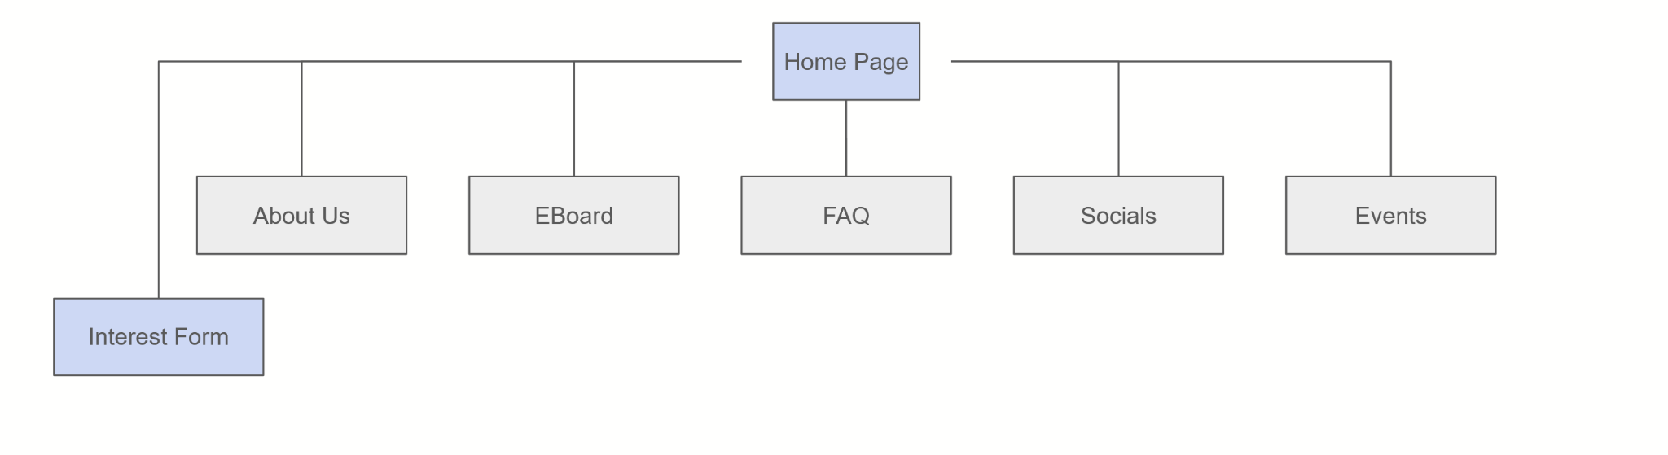

**NEWER Information Architecture**

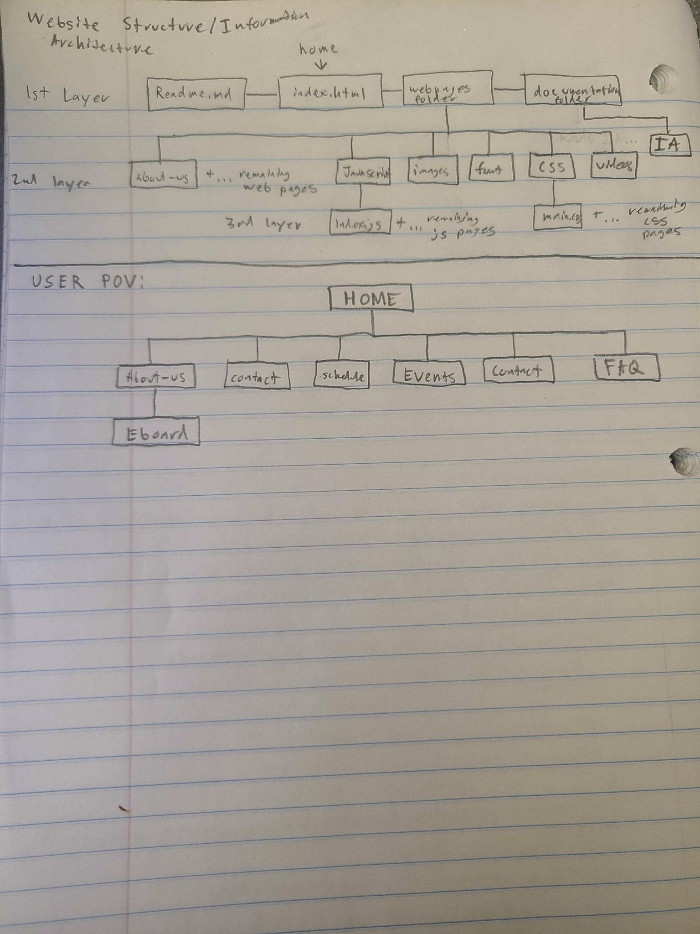

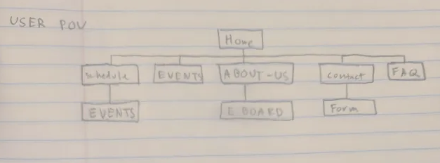

**Current Progress:**

| Cyrus P. | Dathan L. | Oliver C. |
| --- | --- | --- |
| Double Checked HTML code and planning, checked with validator | Made majority of the web pages and linking | Fixed Java Script Code and Helped with CSS |

**Future Plans**

| Date: | Cyrus P. | Dathan L. | Oliver C. |
| --- | --- | --- | --- |
| 3/6/2025 | Start Working on Contact Page | *finished making basic webpages | Start Working on Events Page |
| 3/13/2025 | Help With JQuery for Website | Help With JQuery for Website | Finish FAQ Page |
| 3/20/2025 | Starting Updating Everything to PHP | Starting Updating Everything to PHP | Getting Data from Contact Page |
| 3/27/2025 | Start Making Website more Dynamic | Make Sure Website is User Friendly | Database setup |
| 4/3/2025 | Help with Pitch Planning | Start Planning for Project Pitch Video | AJAX/SQL Implementation |
| 4/10/2025 | Make Final Touches | Make Final Touches | Make Final Touches |
| 4/13/2025 (PRESENTATIONS) |  |  |  |

**Overall Enthusiasm:**

**Around 50% done, morale will be high after data structures.**